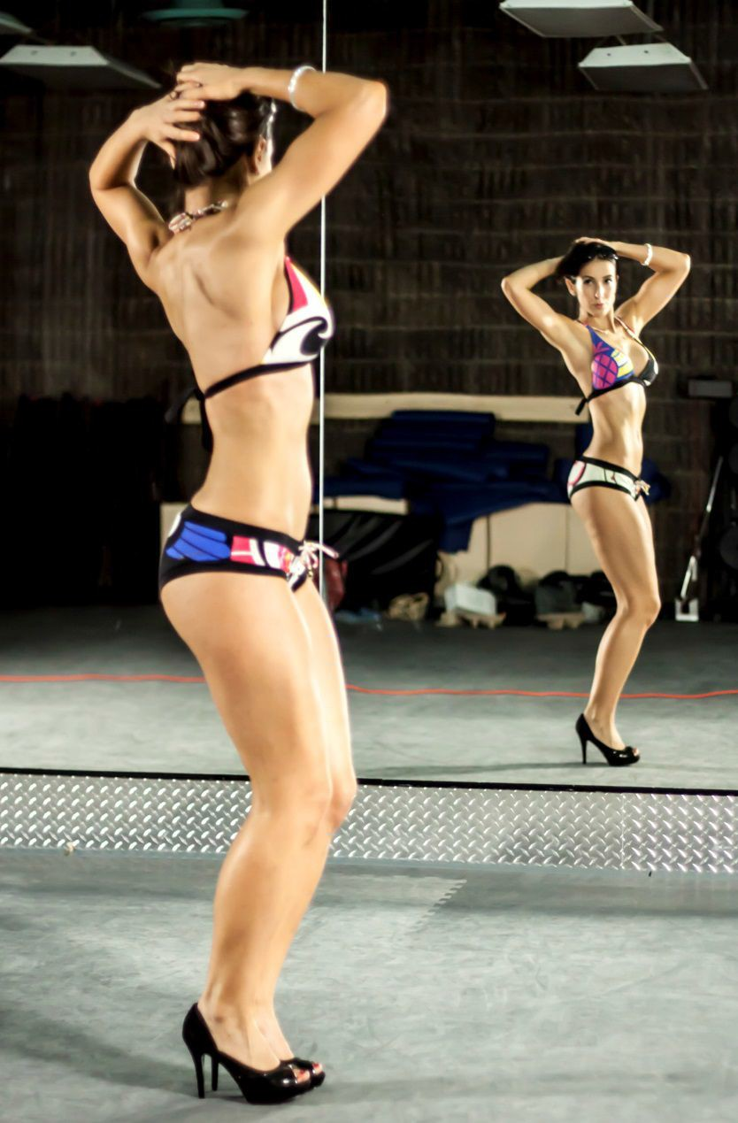
Tania Henriques:

How did I get to being picture ready?

The main ingredient was months of physical preparation working out 3 days a week with [Phase 1 & 2 of the Venus Index] weight lifting workouts. As I'm not big on spending lots of time on purposeless cardio anymore, I tend to get an incidental amount through evening strolls, weekend hiking, rollerblading, cycling and social dancing.

I monitored progress with weekly waist/hip circumferential measurements and weigh-ins, done at a standard time; usually after a day of fasting first thing in the morning.

I used Google calendar to track my progress. I made different colored calendars for different things I wanted to track (i.e. "forward" days, "backward" days, workouts, & metrics).

In the last month a leaning out of body fat was needed. So I aimed for my weekly calories to come in at (RMR) maintenance using 1-2 24hr fasting days a week to allow myself to occasionally have the higher day for social events. I use iPhone notepad app and MFP for daily calorie estimating. I also use a spreadsheet app to track my weekly calorie totals. This helps me quickly see my week's forecast of activities/social events and adjust my calorie intake and fasting days accordingly to still be able reach my weekly intake goal.

My iPhone helped me keep in touch with my support system comprised of the Venus Index Community Forum, Facebook friends (with the same goal - now "The Venus Journey" group), my texting buddies and my journal (in a diary app) so that I could properly process stressors and emotions (so I wouldn't eat them!).

Two to three weeks out I booked a professional photographer (actually he's building his portfolio so I got it done for free!).

Having the date set gave me a hard deadline I needed for the final push.

The last week out I kept diet and fitness stable and started focusing on "the look" I wanted for my photos.

I saved pictures on my iPhone of poses I wanted to try. I made a list of a few props I wanted to use in the shoot.
I picked out my jewelry, bikini and my heels. I would wear them occasionally around the house

and practice poses.

I started taking even better care of my skin. Normally I try to keep it healthy with following:
- Good diet [with plenty of healthy fats],

- Daily sunscreen [& avoid high-noon sun],

- Nightly AHAs [alpha hydroxy acids like glycolic acid to reduce acne, sun-damage, wrinkles, etc.],

- Dry brushing & silicon vacuum cup massage [for improved lymphatic drainage & increased circulation],

- Monthly dermarolling [also known as collagen-induction therapy; i have many scars & stretch marks too and rolling has really helps them fade], and

- Frequent moisturizing with natural oils as moisturizers [i.e. extra-virgin coconut oil, Jojoba oil, BioOil etc - at least it's pretty important in Canadian dry indoor heating & harsh winter environments!

But getting closer to a photo session the motto was: "Exfoliate and Glow!" I used an exfoliating glove in the shower & used a gradual sunless tanning lotion (which I’d apply with a glove). Of course you can simply get a spray tan a day or two before the shoot but be sure to get it done by a good provider!

Photo session day I packed up stuff from my list, did my makeup and put the bikini on under my clothes, showed up and got it over with in 1 hour.

I found it particularly useful to have made decisions about my outfits and prepped a list ahead of time of the things I would bring. I was less stressed overall and thus less likely to chicken out or get frustrated and drop the whole thing!

Retrospectively, although I am generally very happy with the quality of the pictures taken, I do think I could have improved upon it by weight training pre-shoot for more of a "pumped up" look and trialing baby oil on my skin halfway through the shoot to see if that augmented the look of my skin.

