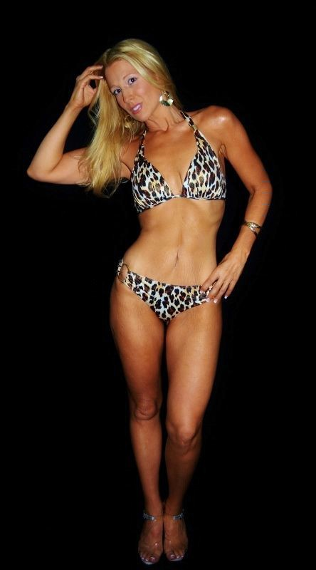
Examples from several contest winners on “The final week”

Sheila Kibe:

I did a water load for my pictures. I got some good information from some of the past contestants and came up with my own variation.

I took three days to record my normal daily intake. Once I established that I added the three days together and divided by three to get my “daily average”. Then I multiplied that number by three to get the amount of water I needed to drink for the three days leading up to my pictures.

I was taking my pictures on Saturday, so starting on Wednesday I drank around 240 ounces each day. This was difficult, but in the end it was well worth it

On Friday, I had to get all my water in by 3 pm because I was stopping the water intake 18 hours prior to my pictures.

On the morning of the pictures I did suck on ice cubes. I would have to say that drinking the water was hard, but going without it was much worse.

Below are my stats throughout the water load. I was a little disappointed at first, but after I cut the water off on Friday I really started pushing out the excess fluid.

Stats Day1 Day2 Day3
Picture Day

Weight 126¾ 126¼ 126 123½
Waist 25¾ 25½ 25¼ 24¾

As far as my dieting the week of the contest…..I stayed under or around 1000 calories each day. I did not want to overeat and ruin what I had worked so hard for.

I also did some fun things like getting a manicure and pedicure. It was a nice reward.

