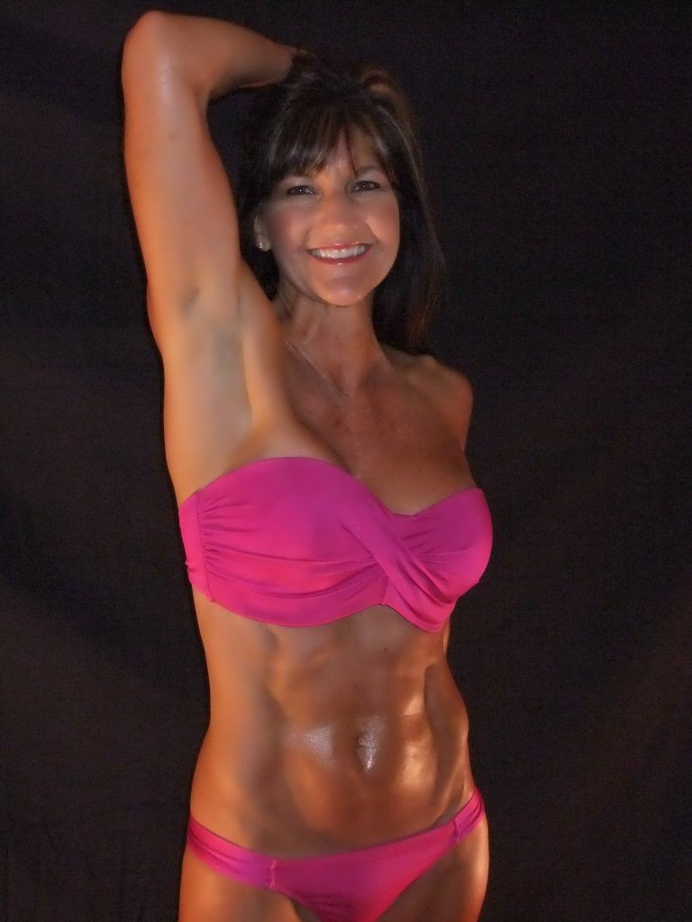
Rhonda Inabnit:

The final week of the contest is the most exciting! The culmination of all your hard work comes together with the photo shoot. It is well worth it to be organized and ready so that on picture day your only job is to take your very best pictures!
Diet prep - I started a fast 24 hours before the shoot was scheduled and water deplete about 15

hours before. I didn't do anything else out of the ordinary. During the morning of the pictures, I sipped small amounts of water, just enough to keep me comfortable. By the time we finished, the fast was approaching 30 hours and I was ready to eat!
The best part of all is looking through your pictures and realizing that no matter how the contest

comes out, you now have beautiful pictures to appreciate forever just how much you accomplished!

