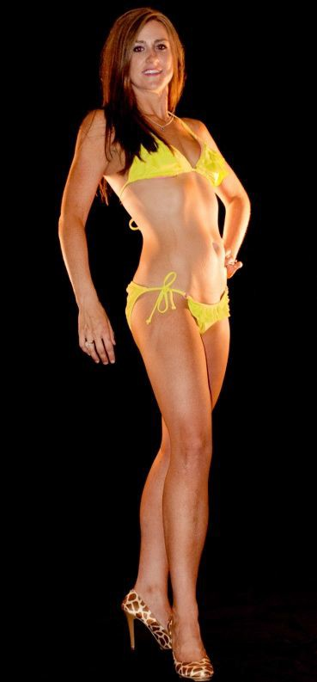

Liss Graham:

5 days before the photo session:

- Start 24H fasts (dinner-dinner), I made my nightly meal high protein with lots of veggies, lower carb. I like to finish with Greek yogurt and fruit. I make sure to take a multi- vitamin.

- I do not drink carbonated beverages this week.

- If needed, I started wearing a retainer at night for straight teeth.

4 days before the photo session:

- Print out posing examples.

- Started teeth whitening strips daily until the photo session.

- Continued 24 hour dinner to dinner fasts until the photo session.

3 Days before the photo session:

- Start water load (aim for at least 2X's regular intake). I also take magnesium/calcium tablets to prevent cramping.

- Continue teeth whitening strips daily.

- Continue 24 hour dinner to dinner fasting.

- This is the last day I work out.

2 Days before the photo session:

- This is the last day I eat any carbs.

- Continue teeth whitening strips daily.

- Make sure clothing is cleaned, pressed, and fits.

- Exfoliate in shower that night to prepare for tan.

- No more working out.

- Continue water load.

- Continue 24H dinner fasts.

1 Day before photo session

- Small breakfast- then fast until photo session

- Continue teeth whitening strips daily.

- Optional glycogen deplete workout (light weights, high reps, full body).

- Get spray tan.

- Start water deplete between 2-7 PM, I did not drink any more than small sips when necessary

- Pack up outfits, props, and mirror.

The day of the photo session:

- Buy a newspaper if you are doing this for a contest.

- Do last teeth whitening treatment.

- Touch up tan.

- Darker makeup than normal (lighting washes you out, so EVERYTHING needs to be applied in a deeper color- base, eyes, blush, lips) and simple hair (straight or lightly curled, and take an elastic to put hair up in some photos).

- Little to no water until end of the photo session.

- Pump up before shoot (lunges/squats, pushups, curls, calf raises)


Here is my comparison from a week out to photo shoot day:

Weight Shoulder Waist Hips

1week out from shoot

145.2 40.5 27.5 37.5

Day of shoot

141.2 41.5 26.5 37.25

VI GOAL
for 5’9”

141.6 42.65 26.36 37.43

