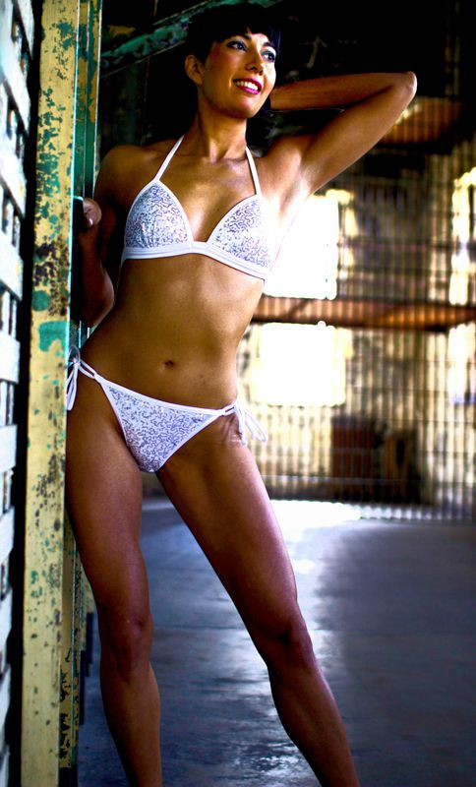
Carla Mar Hill:

There is no substitute for planning ahead and doing the hard work of executing a smart nutritional plan and targeted resistance training several weeks before your special event. You must think far enough in advance before a special event to arrive 7 days out within striking distance of your final product. But if you have done all the proper prep work, there are many things you can and should do during the 7 days leading up to your event so that when the special day arrives you will look and feel your very best. Here is my special 7 Day Recipe for Event and Photo Shoot Prep:

T-7 Days Out: Plan your nutritional strategy. The most important thing you can do nutritionally during the final 7 days is to eat foods that discourage bloat or puffiness. Make a list of the items

you know to be the least inflammatory and head to the grocery store to stock up. Zero carb diets are usually not necessary, but cutting back on and keeping your starchy carb and sodium intakes to a minimum is always beneficial. Sit down with a notepad and your calendar and create your Master Plan for the Final Week. Make an outline of your planned nutritional, hydration and workout schedule and write everything on your calendar. Schedule absolutely everything including time for posing practice in your bikini and heels. Also, don't forget to make lists of products you need to buy, schedule any appointments like tanning, hair and makeup, and massage, and create a detailed hour by hour schedule for the day before and the day of your shoot. Think and plan ahead and you will avoid making mistakes or forgetting crucial items.

T-6 Days Out: Begin your water load. For my shoots, I tried to drink 7 to 10 liters of water per day. Be aware that this will take a toll on you physically and mentally. You will feel water logged, stressed out, and you will become sleep deprived from late night trips to the restroom. This is all the more reason to have planned and written out your Final Week Strategy.

T-5 Days Out: Make this your last intense resistance training day. If you are not doing a spray tan, begin implementing yourself tanning strategy.

T-4 Days Out: Rest from exercise today. If at all possible, take a long nap. Spend time in meditation and visualization of what your D-Day will be like, how you will look, how you will pose. Be sure to follow this up with a posing practice so you can try out the ideas you came up with during your visualization session. Today is also a good day for a professional massage so you will still have time to flush out any toxins released during the treatment.

T-3 Days out: One last 45 minute full body training with light weights and body weight only. Don't make any radical changes to your diet. If you like how you are looking, keep doing what you've been doing. Take an assessment of your condition. If you are feeling puffy, take a second look at your sodium intake and starchy carb consumption and make any necessary downshifts. Don't forget to practice your posing and head to the store for any last minute purchases.

T-2 Days Out: I like to do some very light cardio on this day, just to shake out any extra toxins. Walking or slow elliptical is the best. One final posing practice today!

T-1 Day Out:

Today is a rest and mental prep day. By now you should be pretty tired, so take it easy. Go over your lists and make sure you haven't forgotten anything. Begin to gather up everything you will need for your photo shoot or event and put them all in one place. Get lots of rest. Work on your tan. Stop drinking water by dinner time. Keep your dinner light and low in starch. Hopefully by now you already know how you react to certain foods. I know that sugars fill out my muscles. I like to enjoy a sugary dessert the night before an event like ice cream, crème brûlée, or strawberries with brown sugar. I also enjoy a glass of wine or a vodka cocktail to help dry me out overnight. Sleep can be an issue the night before an exciting event. I like to lie in bed and visualize. This calms me, prepares me, and helps me sleep.

D-Day: Hopefully today you will wake up rested, defined and dry. For a little extra pump, I like to have a sugary and high protein breakfast of jams/jellies/crepes with sugary sauces, and lean breakfast meats like ham or turkey bacon. It's okay to sip some water, tea or coffee, but try to keep your fluid consumption low until your event is over.

Now, go put yourself together and have a beautiful day rocking your Venus look!

