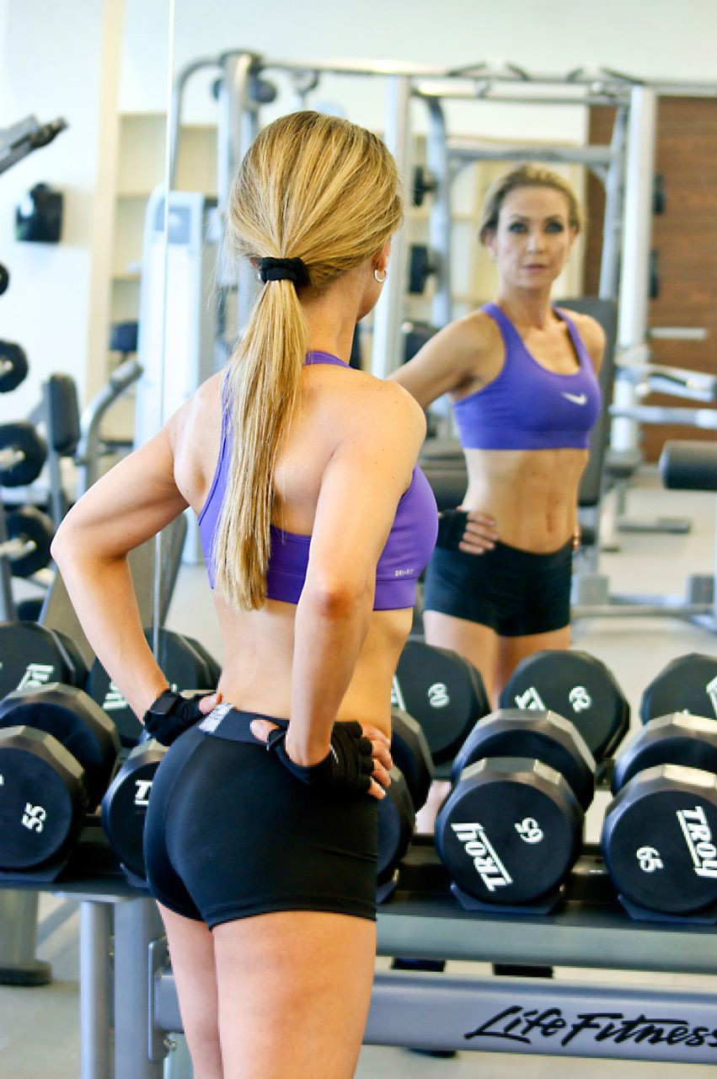
Examples from several contest winners on “The final week”

Barbara Highland:

Sunday - I did my workout and on the evening I removed all my body hair with a Silk Epil.

Monday - I did my last workout. After the workout I took a steam bath at the gym and exfoliated all my skin with gloves and apricot scrub. That night I started self-tanning lotion called Fake Bake. I am very pale normally so applied it to my whole body and neck but not my face.

Tuesday – Because of the tanning lotion no gym workout. I had a pedicure done that morning. This evening I drank a strong herbal laxative tea and applied another coat of the Fake Bake.

Wednesday - No workout and no food that day, just three green smoothies and a lot of plain water. I am very scared of water pills because the last time I used one. I decided to stay with natural remedies and drank three cups of parsley tea with hibiscus flowers to help getting rid of any excess of water. In the evening I applied another coat of Fake Bake.

Thursday – photo shoot day: No breakfast and no water, just one cup of regular coffee.

